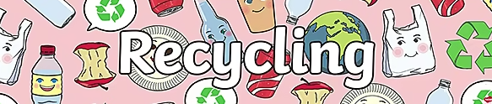

__________________________________________________________________________________________________________________________________________________________________________________________________________________________________________________________________________

**My recycling day report.**

Draw a picture of your recycling bins and bags that you had to fill and then colour them in.

Draw a picture of the recycling lorry that came to collect your rubbish.