Beach Time
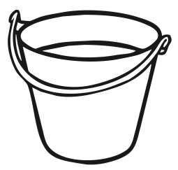
LI: To understand what you would put in your bucket when we go to the beach.

