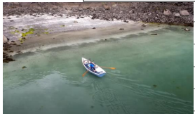 | All around, the crystal-clear water was as smooth as a mirror. Feeling excited, Danny arrived at the deserted beach. Drifting slowly, the little boat came to rest on the sand With a gentle splash, Danny hopped out of the boat. Ready for the adventure, he grabbed his trusty bike.
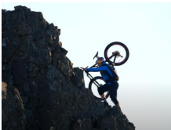 | Clinging to the rocks with one hand, Danny made his way up the colossal cliff. In front of him, loose rocks were falling down. Minute by minute, Danny rose higher up the mountain. Taking it slowly, he made it to the highest peak.
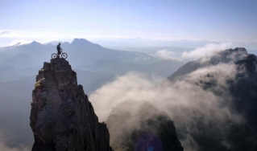 | All around him, the clear blue sky stretched out forever. In the distance, the sea glistened in the sunshine.  Far below, the misty clouds swirled around like smoke. Surrounding the peak, jagged rocks stood up like sharp teeth.
