Writing Complex Sentences With Verb Starters

Complete these complex sentences by writing a main clause at the end, or a subordinate clause at the beginning with a verb starter (-ing word).

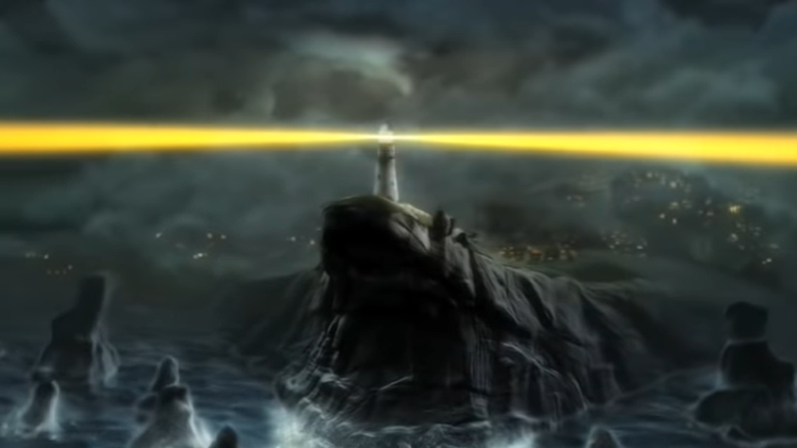 | Flashing brightly, the lighthouse towered up into the clouds.  Fighting the darkness, the yellow light cut the clouds like a knife.  Pelted by spray, the lighthouse stood at the top of dangerous cliffs.
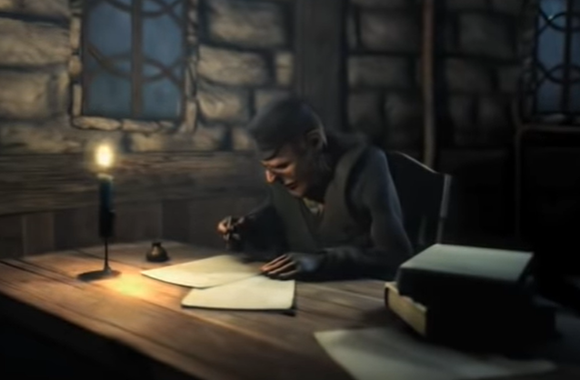 | Sitting at his desk, the lighthouse keeper _____________________  ______________________________________________________  Reading the words carefully, the lighthouse keeper ____________  ______________________________________________________  Resting on a chair, the lighthouse keeper _______________________
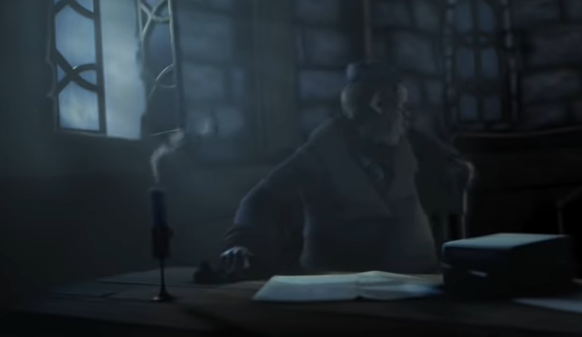 | Making a loud bang, the window ___________________________  ______________________________________________________  Feeling shocked, the lighthouse keeper ______________________  ______________________________________________________
Peering into the darkness, the lighthouse keeper ______________
______________________________________________________
Holding an old oil-lamp in front of him, ______________________
______________________________________________________

Flickering constantly, the oil-lamp __________________________

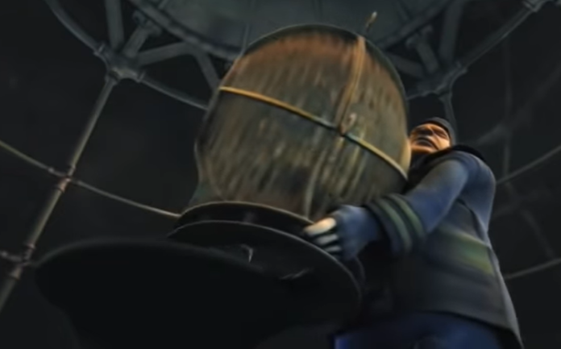 | ______________________________________________, Quentin rushed to find the problem with the lightbulb.  ___________________________________, Quentin lifted the heavy lamp-housing off the giant lightbulb.  ________________________________________, Quentin tripped over the toolbox which he’d left on the floor.
___________________________________________, the villagers watched the boat.

___________________________________________, the villagers peered out to sea.
____________________________________, the villagers cheered!

