Describing British Birds

LI: To join clauses in a sentence using conjunctions.

Describe each bird in clear sentences. Join the ‘chunks’ of information (clauses) using conjunctions:
and because that but so when since

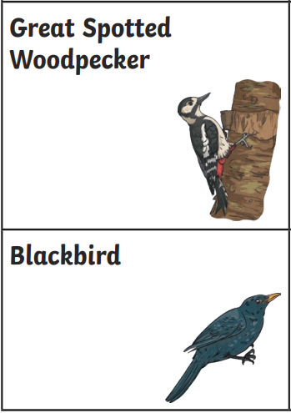
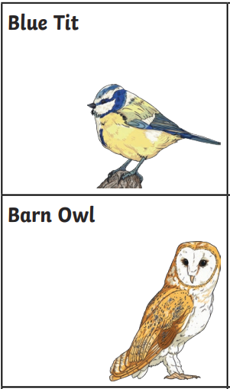

_________________________________________________________________

_________________________________________________________________

_________________________________________________________________

_________________________________________________________________

_________________________________________________________________

_________________________________________________________________

_________________________________________________________________

_________________________________________________________________

_________________________________________________________________

_________________________________________________________________
Blue tits are small birds that have blue, yellow and white feathers. Because most blue tits don’t migrate, they can be seen in the garden all year round, including winter. These cheerful birds forage for seeds and insects, but will frequently visit a bird-feeder for extra food. Blue tits are sedentary birds so will often live and breed in the same area where they themselves hatched as chicks.






















