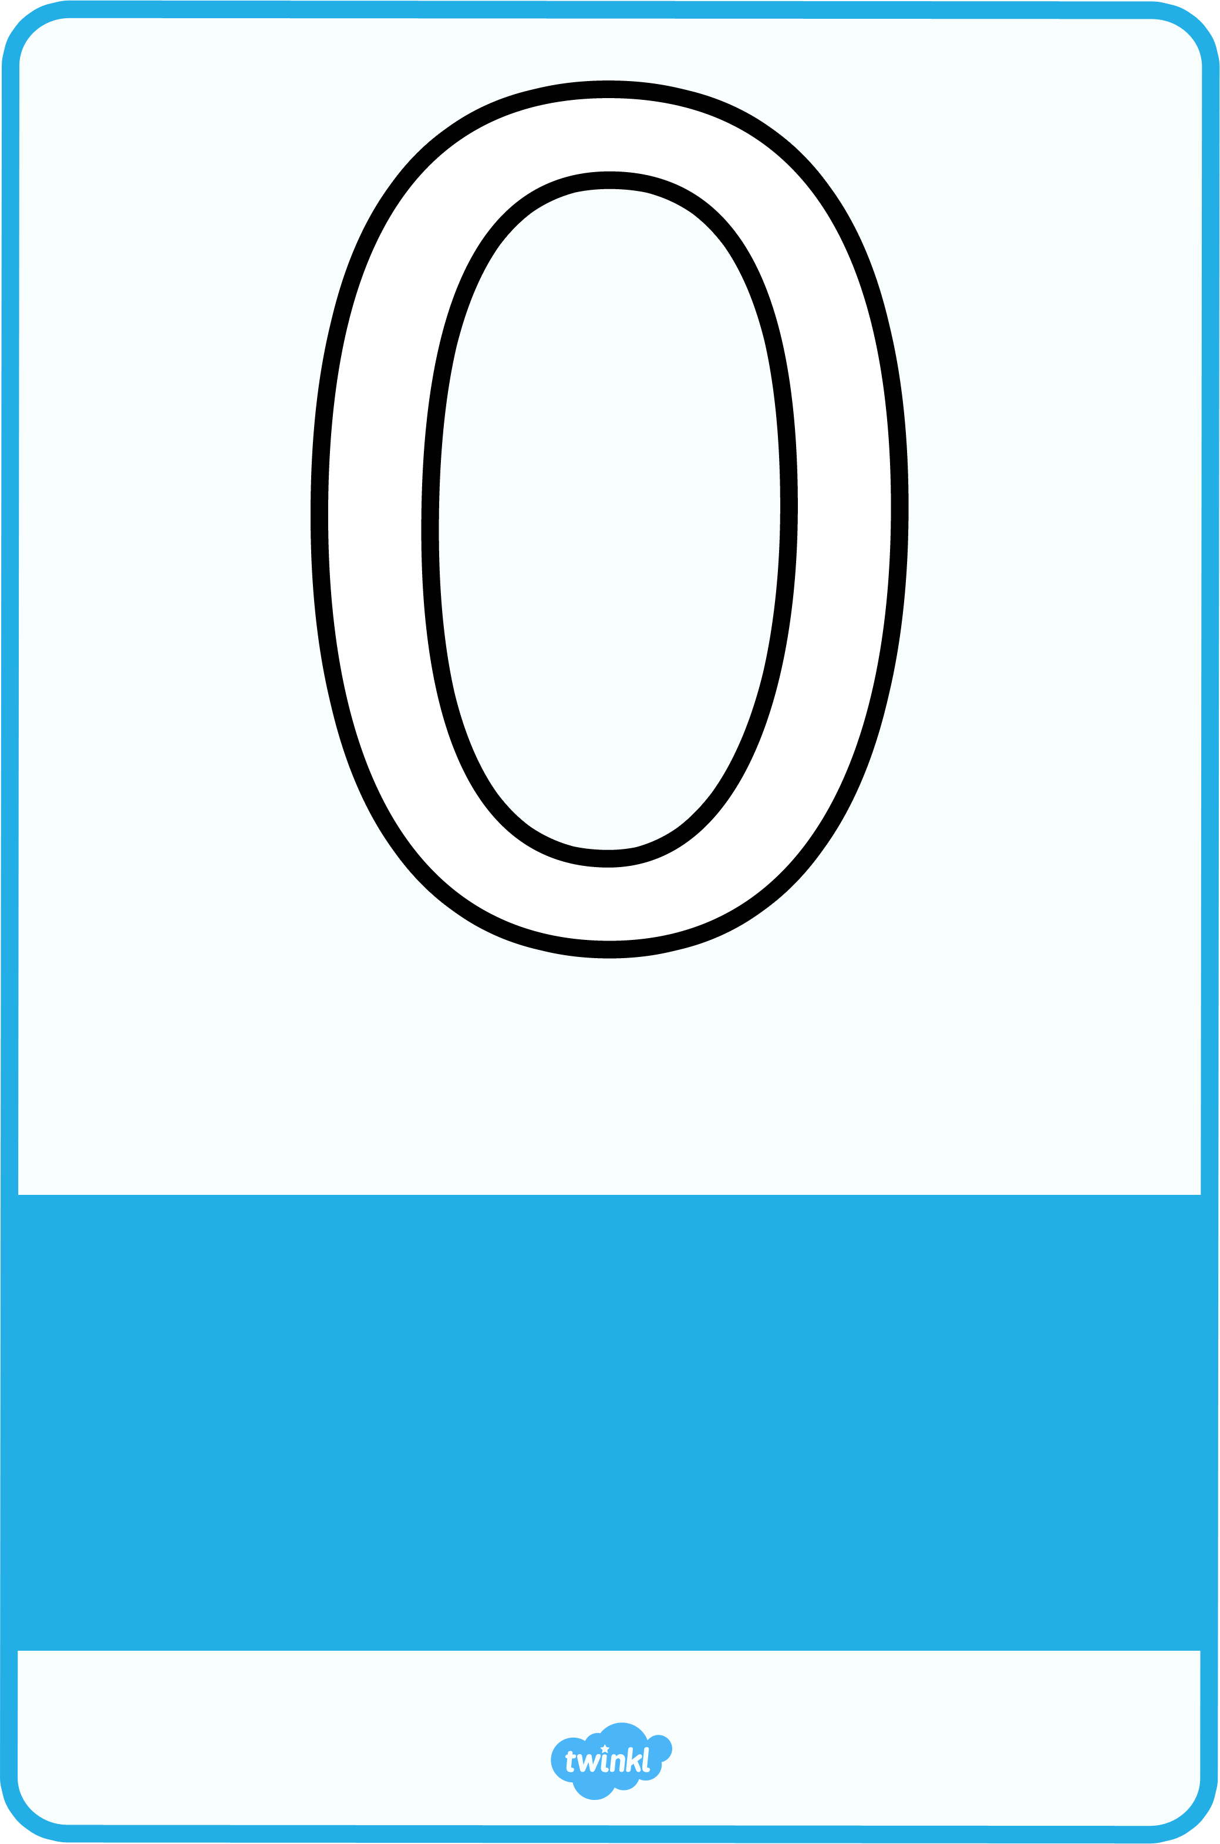

Around to my left to find my hero, back to the top, I’ve made a zero.
zero
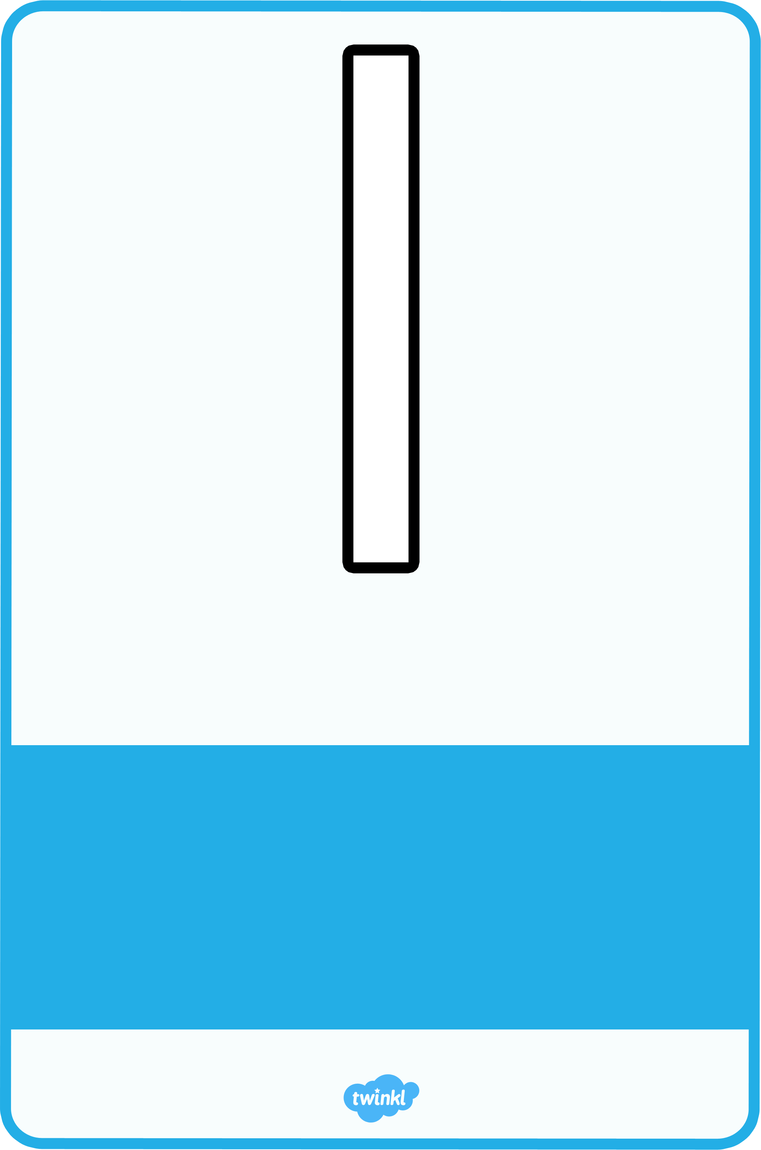

A downward stroke, my that’s fun.
Now I’ve made the number one.
one
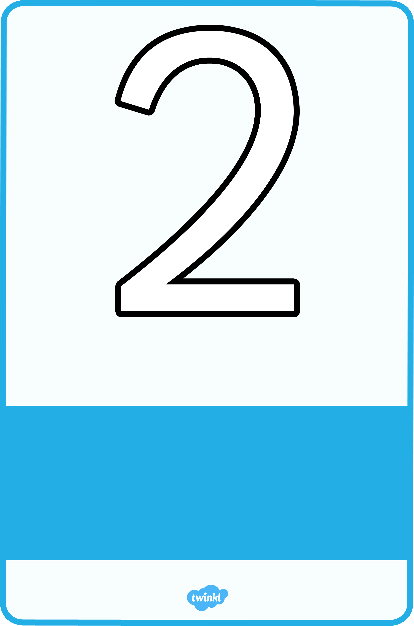
Half a heart says “I love you.”
Add a line. Now I’ve made the number two.
two
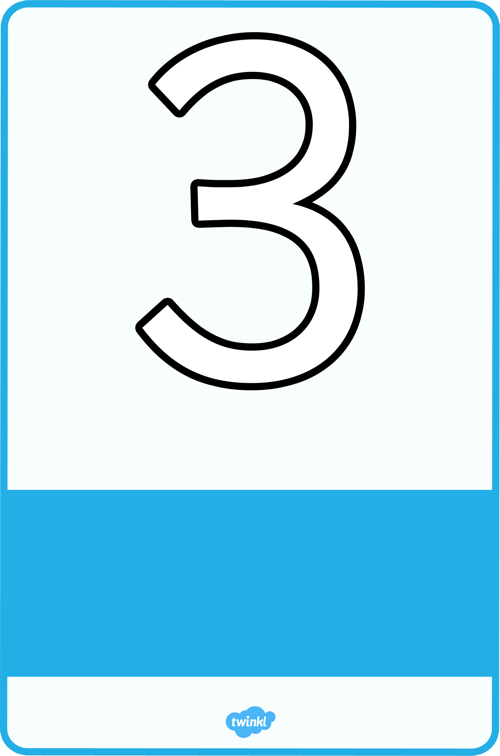
Around the tree, around the tree, now I’ve made the number three.
three
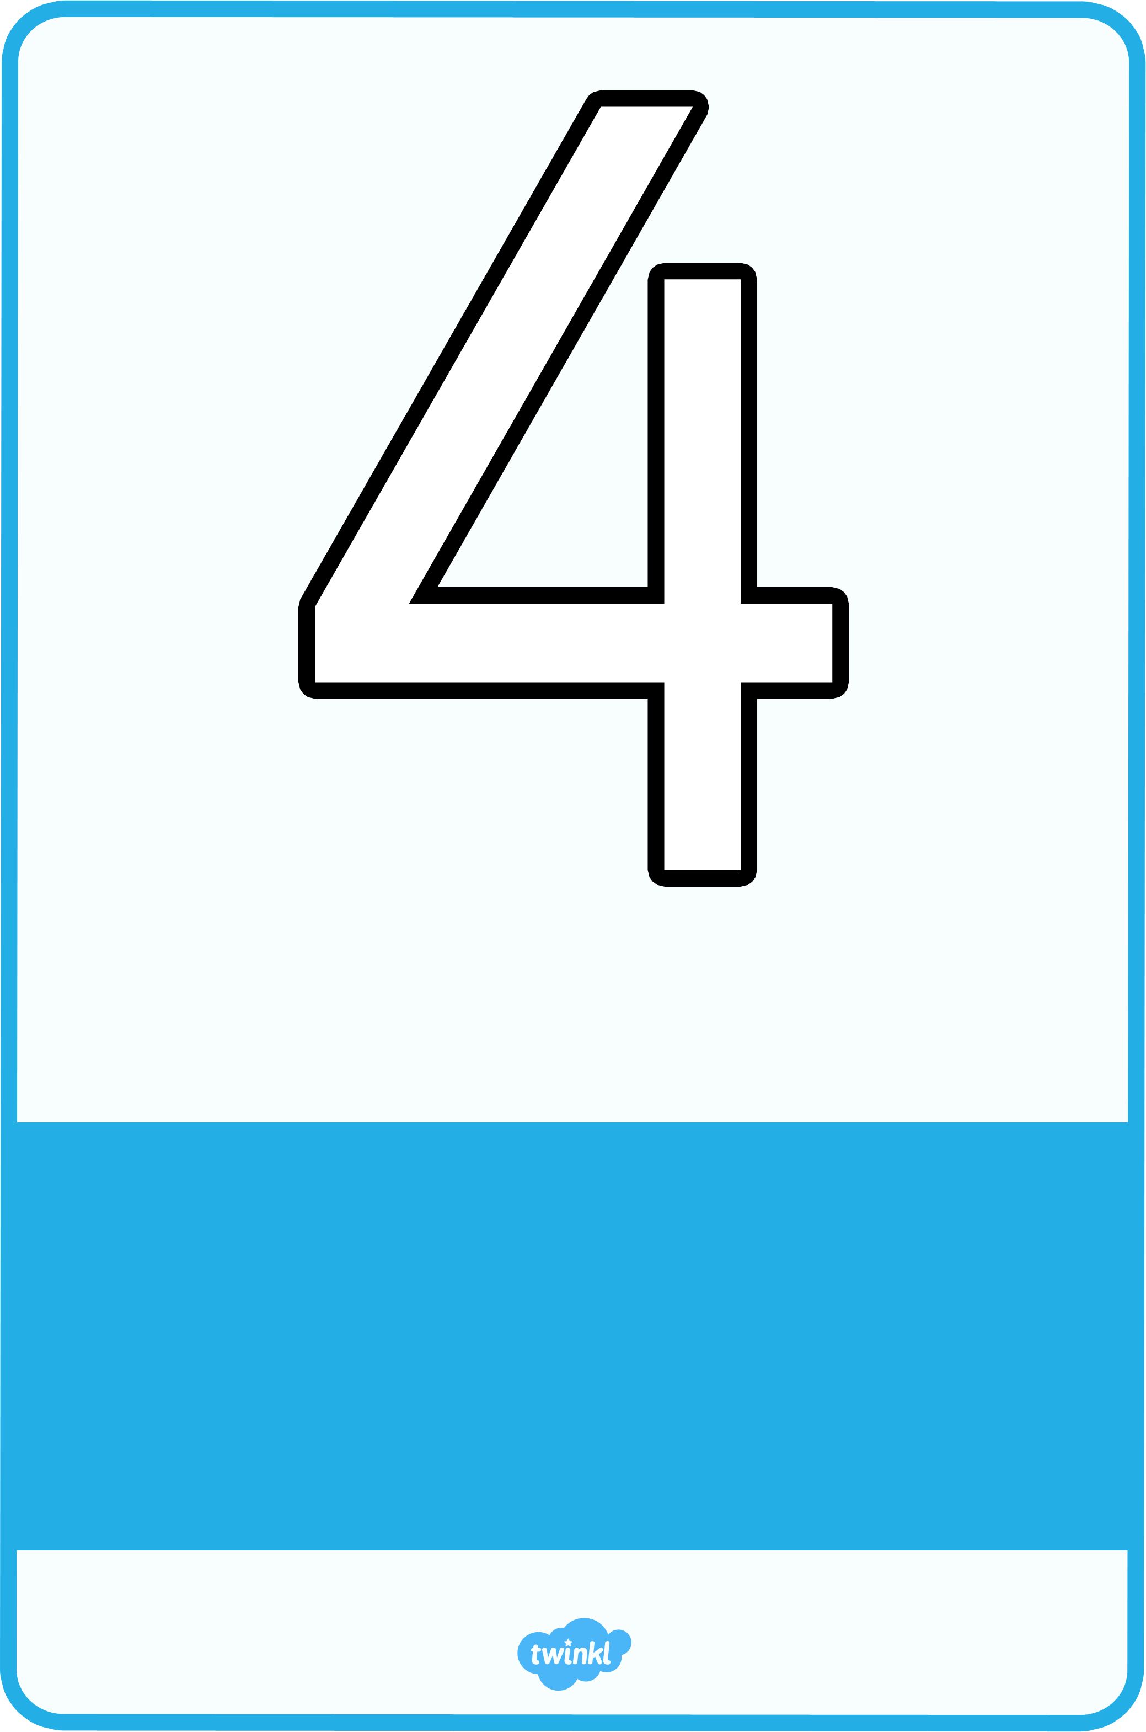
Down and across and down once more, now I’ve made the number four.
four
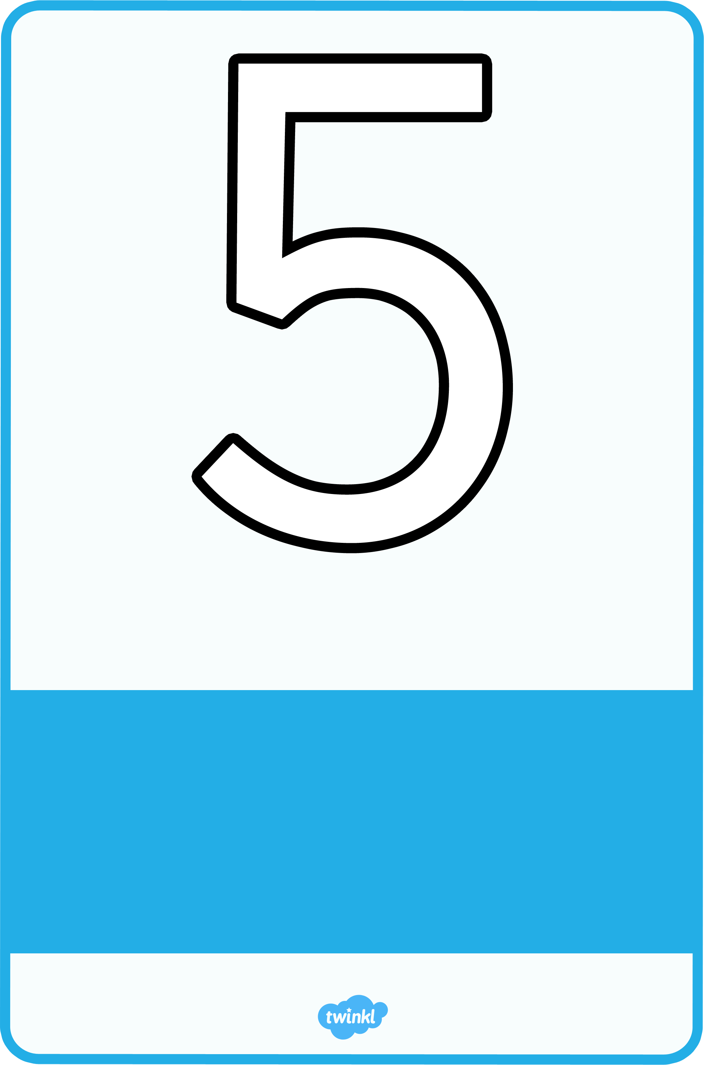
Draw the hat, the back and the belly. It’s a five. Watch out, it might come alive!
five
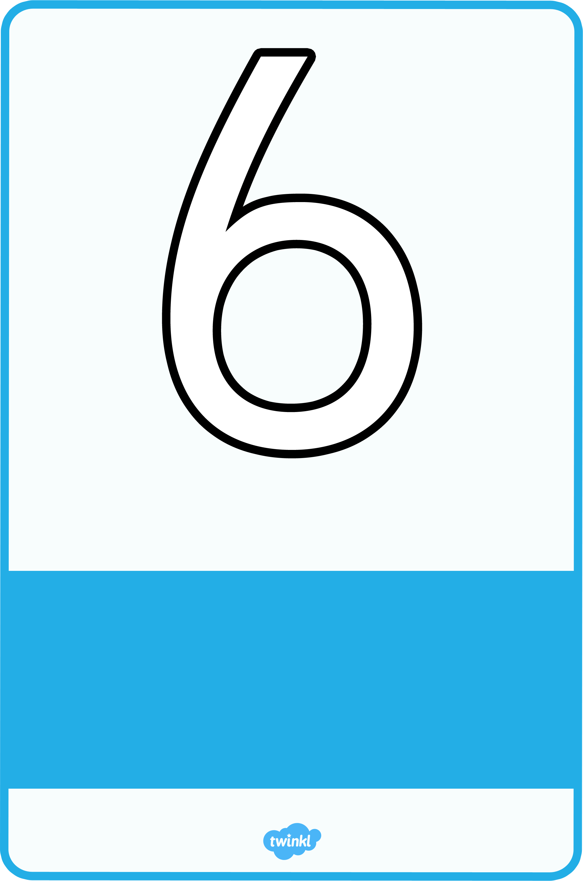
Bend down low to pick up sticks. Now I’ve made the number six.
six
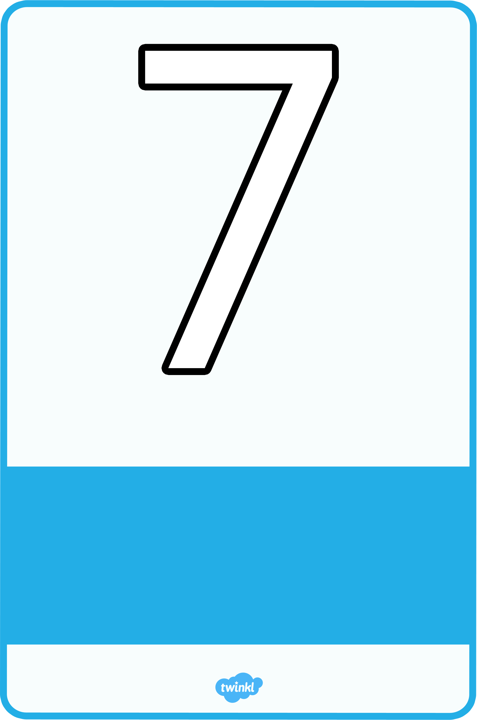

Across the sky and down from heaven. Now I’ve made the number seven.
seven
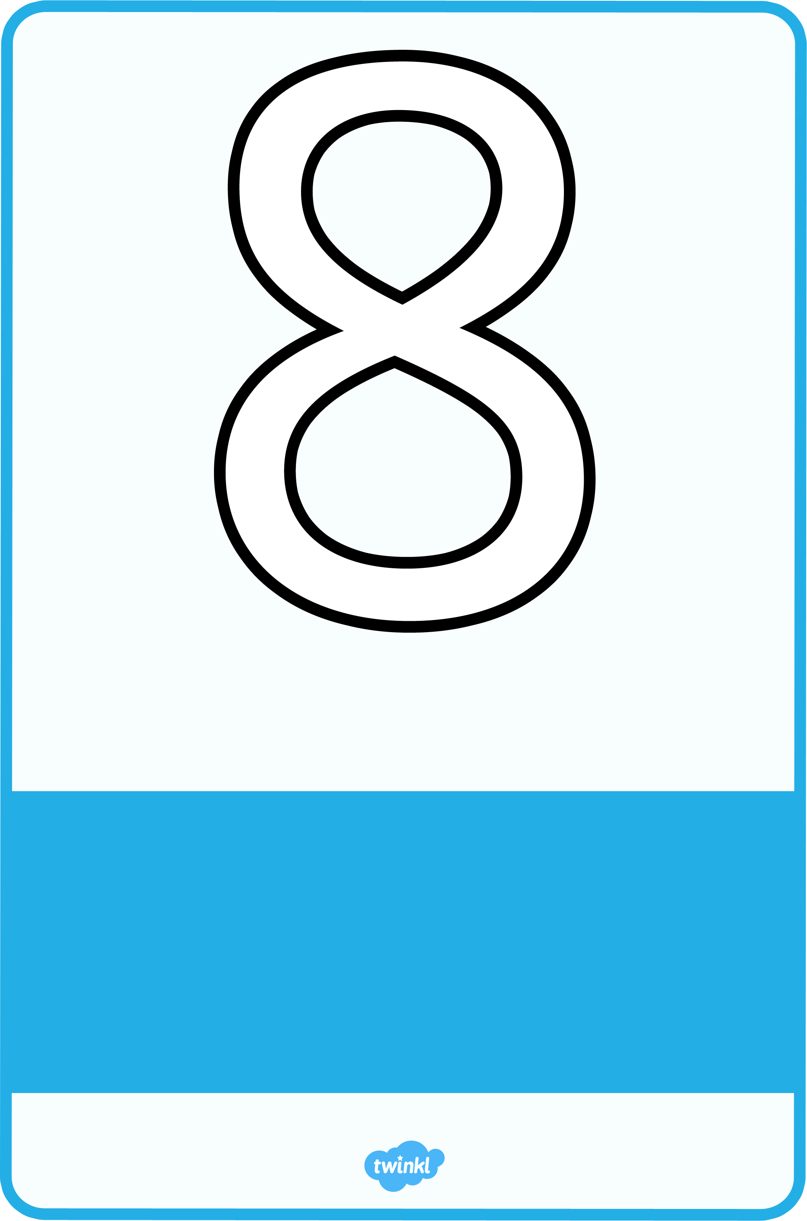
Make an “S” and close the gate. Now you’ve made the number eight.
eight
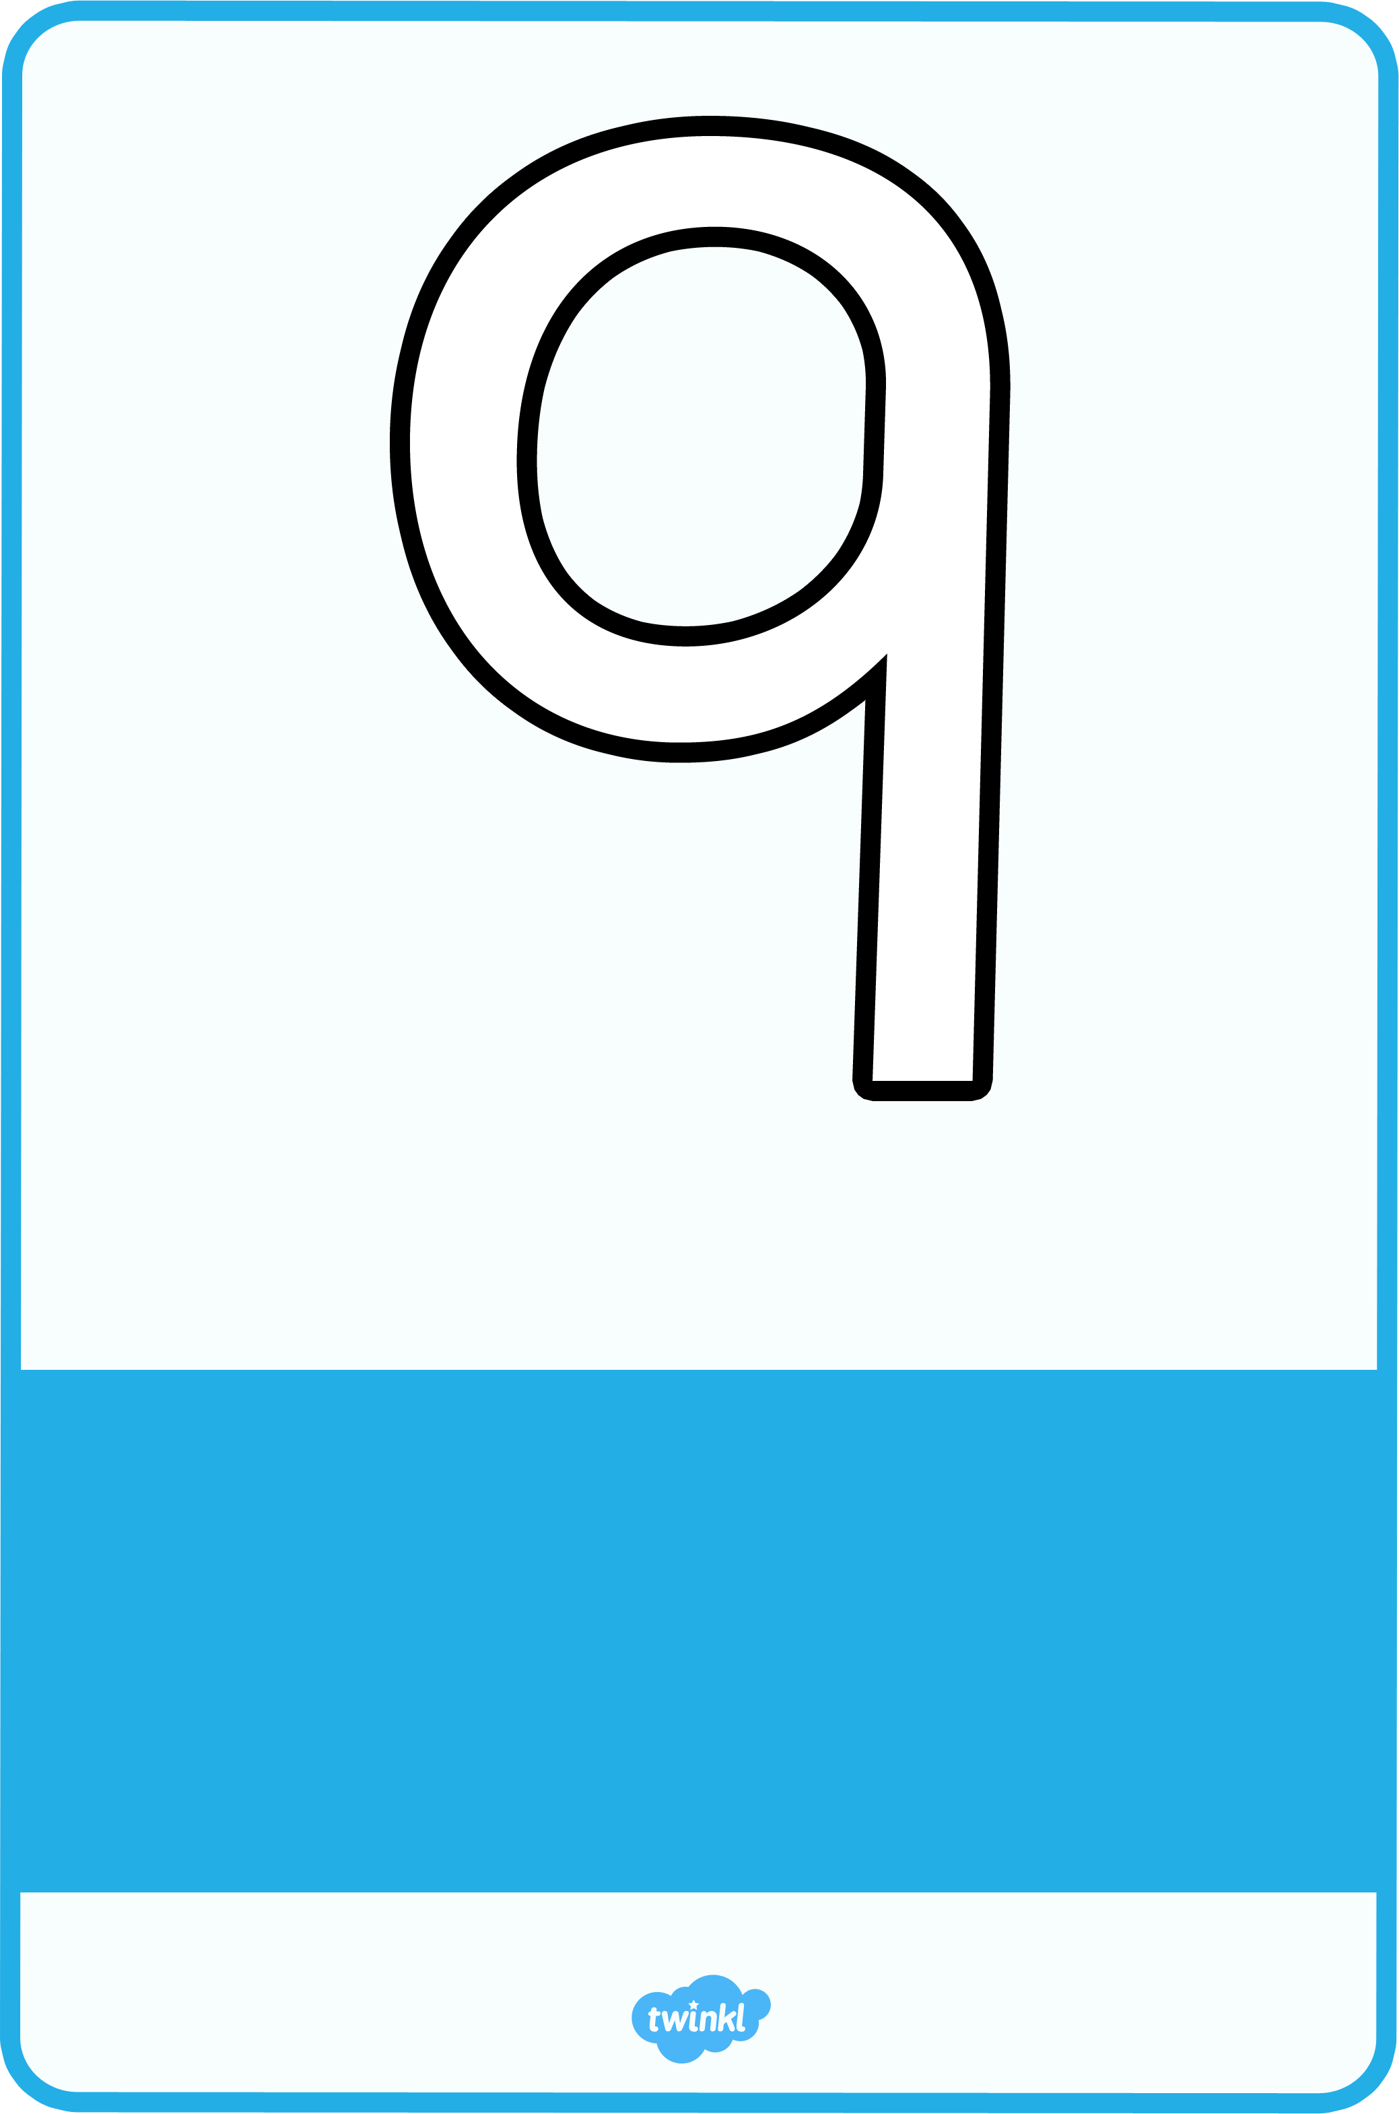
Make an oval and a line.
Now I’ve made the number nine.
nine

