Red Class Comprehension – W/C 6th July

- Comprehension is developing you child’s ability to listen to information and understand what is being said/read to them. Questions are asked to assess their ability to retain the information and share their understanding of what they have heard.

- Please read the extract to your child, making it fun along the way. Think about ways that they will remember the information, maybe through the use of props including toys, teddies, coloured paper and images etc.

- Once you have read the extract to your child, read one question at a time. You may choose to reword trickier questions.

- Encourage your child to give their answer as a full sentence. For example, question 8 asks, ‘What colour is the flag that means danger’. Rather than your child saying ‘red’, encourage the following, ‘The red flag means danger because you can’t go in the water’ or ‘The danger flag is red’.

- Encourage your child to write some of their answers down, using their sounds to sound out words as they write. There are a few questions so either split these across a couple of days, remembering to re-read the extract each time, or take it in turns so you write the answer to one and they write the answer to one.

- Please remember - When supporting your child with their writing it is important that you allow them to use their phonic knowledge to write words in ways which match their spoken sounds. Therefore if your child is writing the word fish and they can't hear the 'sh' sound at the end this is where they are developmentally and it is important to support that. In class we would add a little annotation in a different colour pen after their writing to help add meaning to their marks.
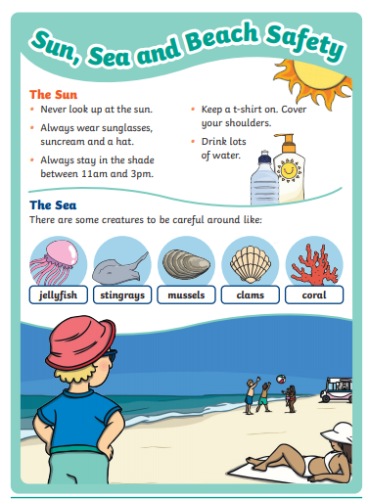
Introduction to beach safety and part 1 of the main extract.

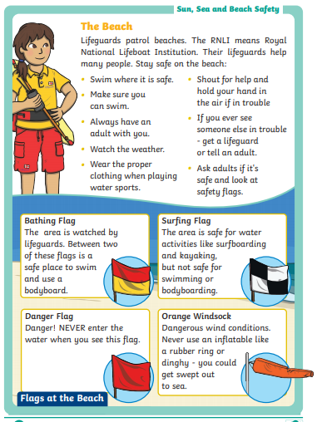
Part 2 of the main extract
