LOOK AT THE 60s !!!
Boys’ Fashion

At the start of the 1960s, cuffed jeans and corduroy trousers were favourites, and denim remained popular throughout the decade.

Jeans were comfortable to work in, but also looked good when worn as casual wear.
- Denim is made from a natural material called cotton.

- It is a sturdy, woven fabric, and is one of the most commonly recognizable materials in the world.

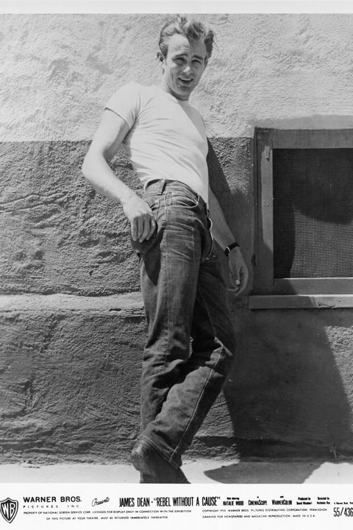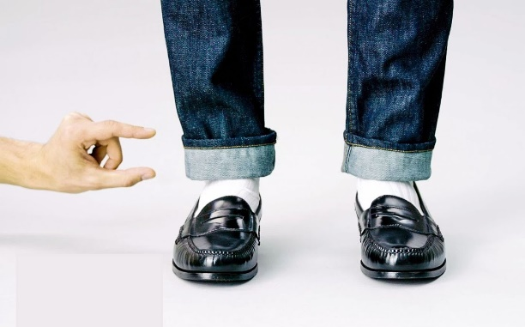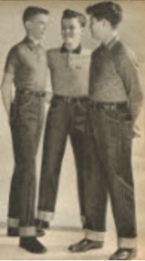

A polo-shirt tucked into the trousers was the everyday, fashionable look of the time, and blazer-jackets would have been worn for smart occasions. The spreading manufacture of polyester (plastic) fabrics meant boys’ clothes could be made in a wider range of colours and patterns. Plaid (tartan) patterns became very popular and stripes were also widely used.

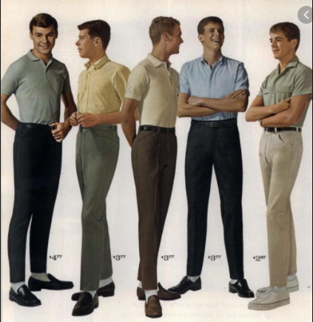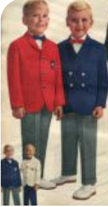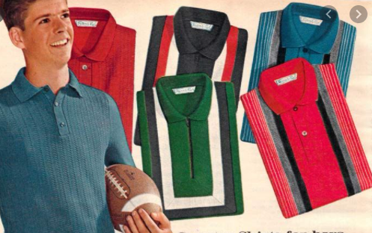

As the 1960s gathered pace, the colours and patterns that were seen in men’s clothing began to slowly creep into young boy’s fashion.

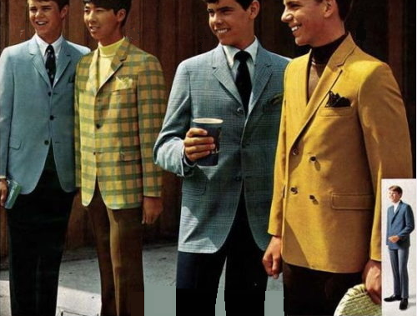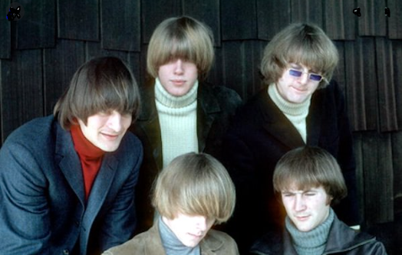

Striped and plaid blazers were popular formal options, while turtlenecks (rolled-collar shirts and jumpers), were a popular style among men and boys, and brighter colours such as red, yellow, and orange were worn in the mid-sixties.

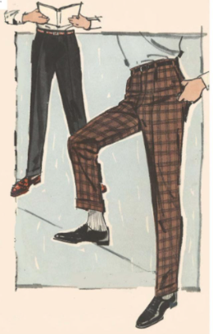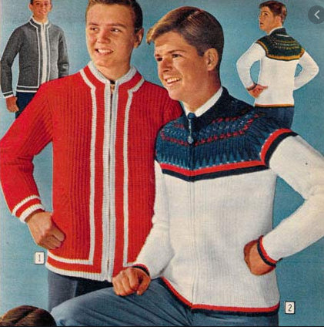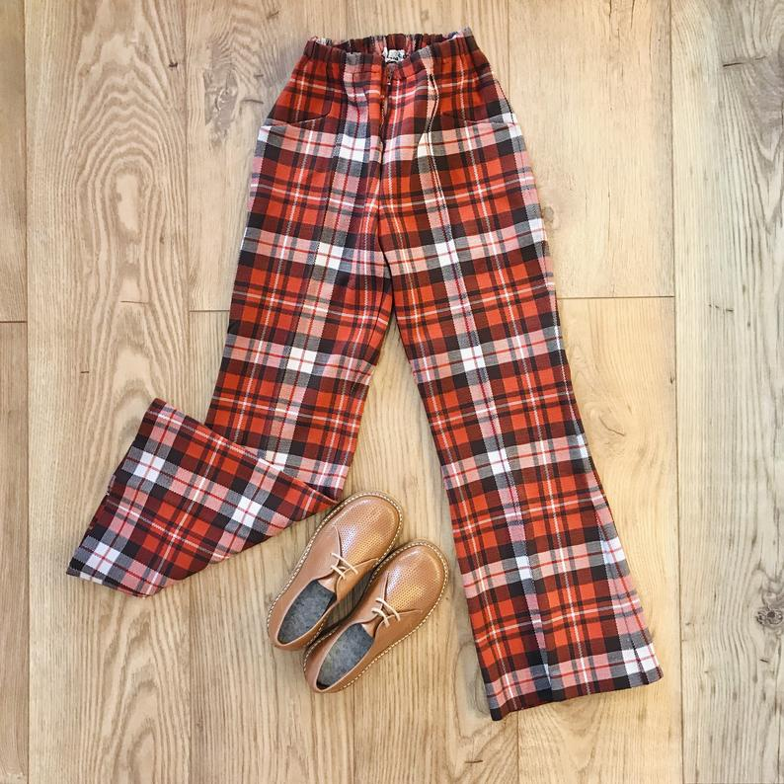

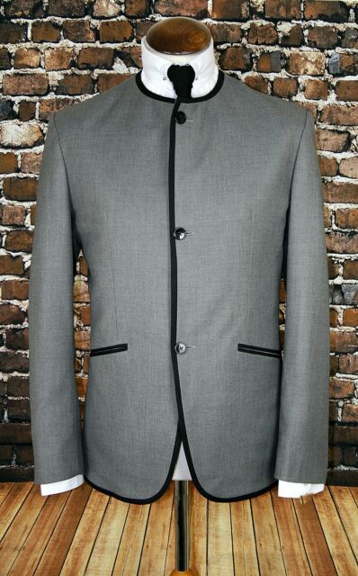
.
As the decade progressed, men’s suits began to include daring new elements like the collarless jacket (a look popularised by The Beatles in 1963, the year they launched their first album) and slim-fitting trousers with heeled boots rather than shoes.

Subtle Big Changes

In the 1960s, the kind of people who were inspiring men’s style was changing. Where movie stars had been the primary style icons since the 1930s, rock stars such as The Beatles, Jimi Hendrix, and Mick Jagger, among others, became a primary influence on men’s fashion.

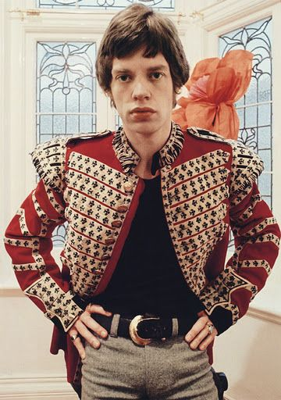
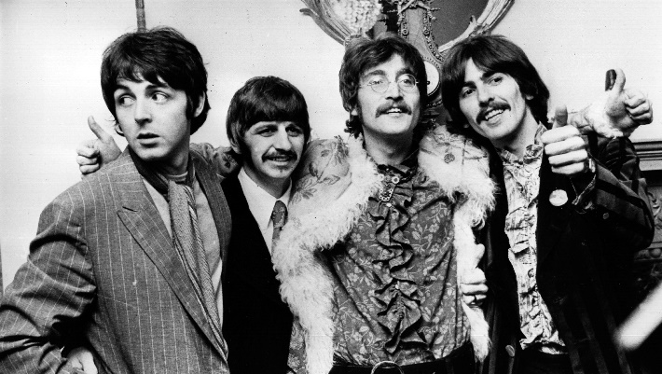

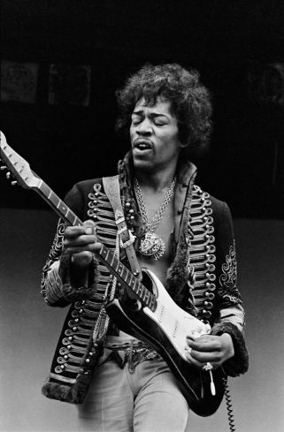
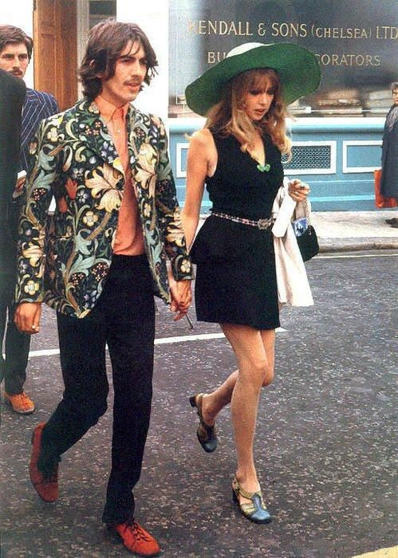
Clothes designers (and wearers) experimented a lot during the 1960s, mixing up colours, styles and materials to find new ways to look good and have fun. Some people combined flamboyant colours with traditional suits, while others experimented with military garments and tight-fitting jeans.

