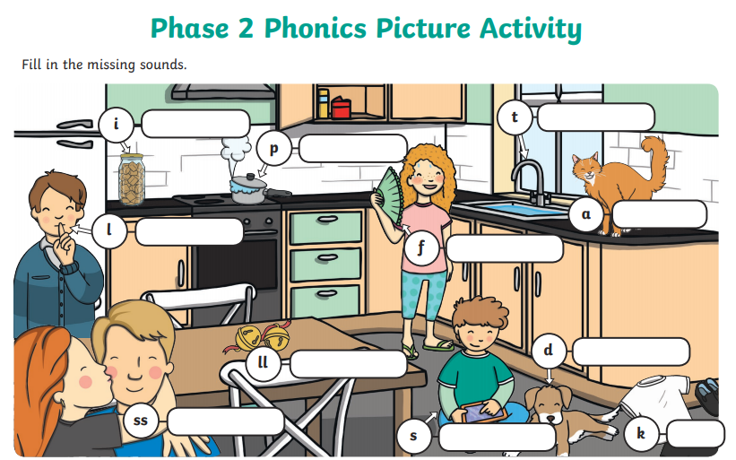

Write each word, linked to the picture. Try and do this independently.