Title: The hungry………

My story plan

Character (Choose one)

____________________________________________________________________________________

Setting

______________________________________________________________________________________

Ending (What happened at the end of your story)

_____________________________________________

______________________________________________________________________________________________________________________________

______________________________________________________________

Beginning (What happened at the start of your story)

________________________________________________

______________________________________________________________________________________________________________________________

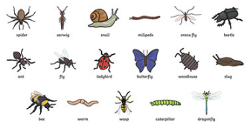

Middle (Think about what your character ate)

_____________________________________________

_____________________________________________________________________________________________________________________________

