Red Class Sentences – W/C 29th June
- Please encourage your child to read these sentences to you.

- Next, slowly, one word at a time read the sentences to your child and get them to write the sentence in their home learning book.

- Each child should be writing two per day.

- If your child would like to write more, which is great, ask them to come up with their own sentence. Please remember - When supporting your child with their writing it is important that you allow them to use their phonic knowledge to write words in ways which match their spoken sounds. Therefore if your child is writing the word fish and they can't hear the 'sh' sound at the end this is where they are developmentally and it is important to support that. In class we would add a little annotation in a different colour pen after their writing to help add meaning to their marks.

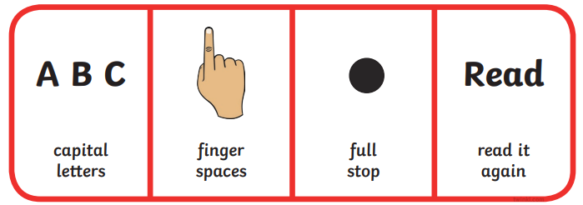
- I can sing a song.
- The queen has a shop.
- The sheep went to sleep.
- I think they are all long.
- The car is stuck on the hill.
- Pick a sweet from the shop.
- I can chop my chips.
- Look at this thin fish.
- The cloth is a bit wet.
- The wind is so strong the door went bang.

