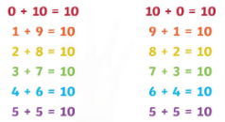

**Number bonds to 10 rhyme**

This can be sang with finger actions to show the number bonds.

5 and 5 add up to 10

6 and 4 make it again

7 and 3 they also do

Guess what! So do 8 and 2

9 and 1, 10 and 0

Learn them all, you’re a number bond hero!