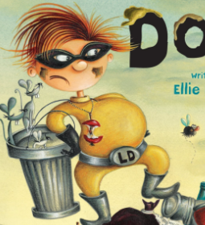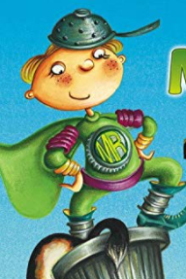

Michael Recycle

Litterbug Doug

WC: Monday 1st February 2021

LI: To describe the characters Michael Recycle and Litterbug Doug.