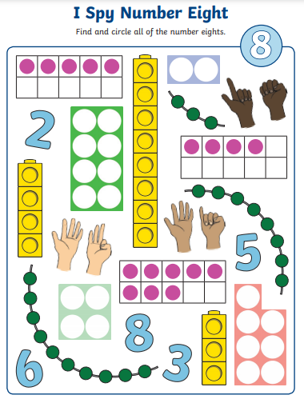
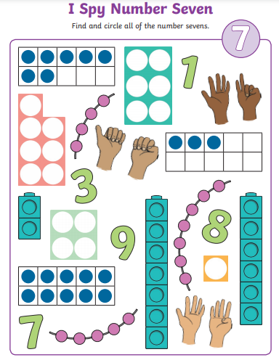
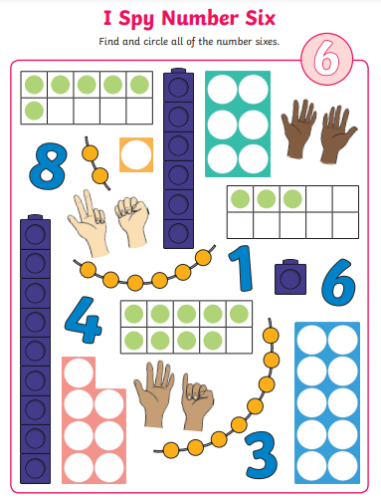
Numeral 6 | Numeral 7 | Numeral 8
Now create your own drawings and representations.
Numeral 6 | Numeral 7 | Numeral 8

