Now Look At The 70s !!!

As time moved on from the 1960s into the 1970s, fashion trends changed, but certain items remained. Fashionable styles of clothing from the 1960s continued to be popular throughout the next decade. However, some elements of the clothes evolved and became recognizable as 70s fashion statements.

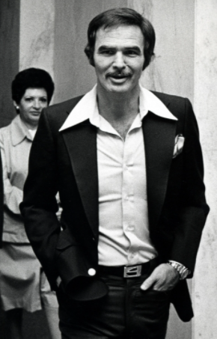
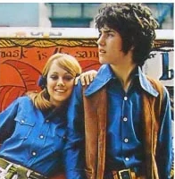
Elongated Collars
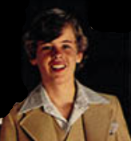
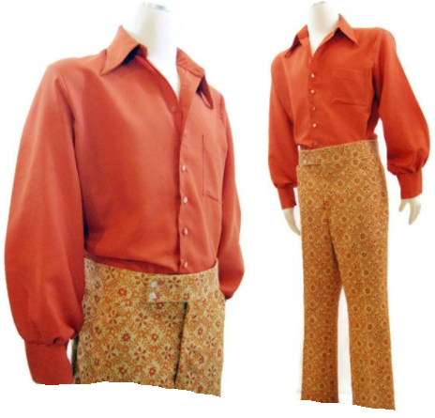

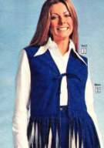
Both men and women enjoyed wearing shirts with wide, elongated collars. These gave the wearer a smar t yet casual appearance. They could be worn either with or without a suit.
Cheap shirts would have been made out of polyester or cotton. Fine-quality, expensive shirts would have been made out of silk - the most comfortable fabric to wear.

Bell Bottom Trousers and Flared Jeans
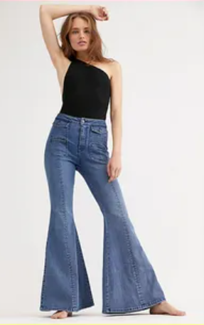
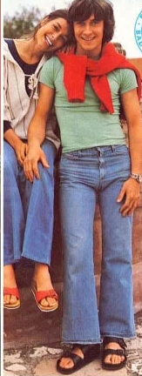
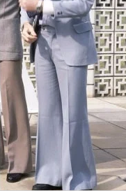
Denim was consistently popular as a clothing fabric throughout the 1970s.

A new style of trouser was invented which had wide openings at the bottom of the legs.

These ‘flared’ trousers were also called ‘bell-bottoms’ because the leg got wider from the knee down, creating a bell shape at the bottom.

Flares came in a lot
of different colours.

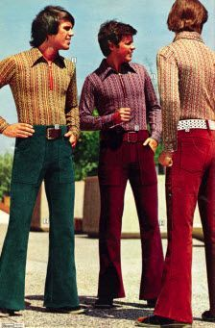

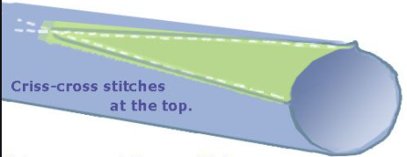

Jeans could easily be transformed into flares by adding a triangle of fabric at the bottom.
Complete the statement:

Fashion ______________ changed in the 1970s, but ______________ items of clothing continued to be popular.

Which word means ‘ten years’ ?

‘…some elements of the clothes evolved…’
Use a thesaurus to find synonyms for the word evolved.

Who enjoyed wearing elongated-collar shirts ?

‘…wearing shirts with wide, elongated collars…’
Use a thesaurus to find synonyms for the word elongated.

Give two reasons why silk shirts were the most expensive ?

Explain why flared-trousers were sometimes called bell-bottoms ?

What was needed to turn a pair of jeans into flares ?

