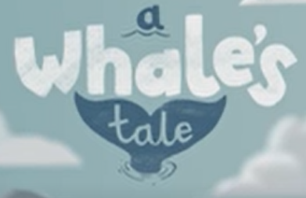

WC 22nd February 2021

LI: To understand what plastic pollution is

**A Whale’s Tale**

S

**Name 3 things that you saw in the video?**

**_______________________**

**_______________________**

**_______________________**

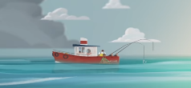

**Should we throw rubbish in the sea?**

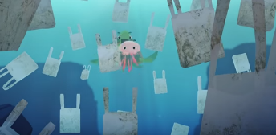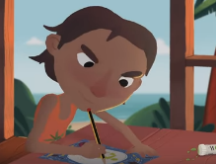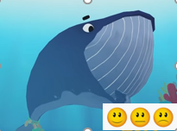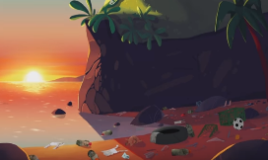

**What did the girl make to help the sea creatures?**

**________________________________________________________________________________________________________________**

**What rubbish was in the sea?**

**________________________________________________________________________________________________________________**

**Where has the plastic come from?**

**________________________________________________________________________________________________________________**

**How did the whale feel?**

**_________________________________________________________________________________________________________________**