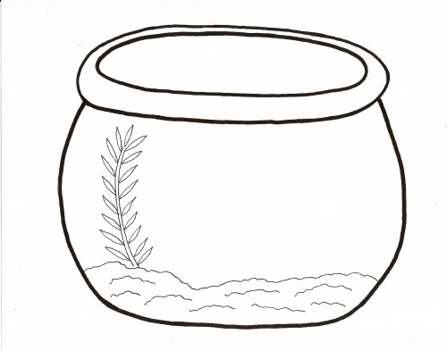
My Fish Tank – Fighting Plastic Pollution

