Roman music

The Romans loved music. It was important to help them relax, tell stories, worship their Gods and send signals and messages. Here is some information about different Roman instruments:

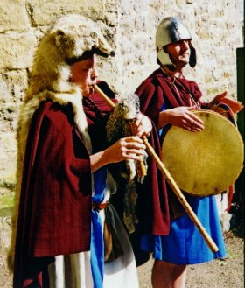
Tympana – a drum or tambourine

The Tympana was a small drum carried in the hand. Some resembled a modern tambourine with bells. The Tympana was covered with the skin of oxen and was beaten with a stick like a drum, or with the hands like a tambourine. They were used a lot in religious ceremonies.

Askaules – a type of woodwind instrument

The askaules were very similar to Scottish bag-pipes. Air was blown down a tube into a leather bag. The bag was then squeezed under the person’s arm to make the sound come out from a different pipe.

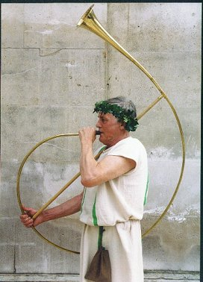
Cornu (horn)
The cornu was a wind instrument made of animal horn or brass. It was a large musical instrument, curved nearly in the shape of a C and had a cross-piece to steady the instrument for the performer.
Different notes were produced without keys or holes. Instead, the player had to change the amount of the breath they blew in to it, or the shape of their lips around the mouthpiece. Any signal or classicum given to lots of people or soldiers all at the same time would usually be sounded with a cornu.

Give 3 reasons why music was so important to the Romans:

What was used to cover the tympana ?

The tympana looked like a tambourine. Which word means “looked like”?

r _ _ _ _ _ _ _ d

What did a person need to do in order to make sound come out from
the askaules ?

How is the cornu described ? Circle one:

Large Small Shiny Loud

Find 2 compound words in the paragraphs about the cornu.
(A compound word is two words joined together.)

What was the Roman word for signal ?

