NAME | Krakatoa Volcano  LI: I can summarise information | Sperm Whale
PICTURES | 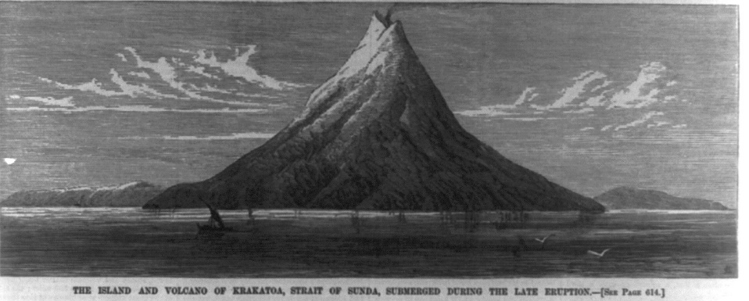 | 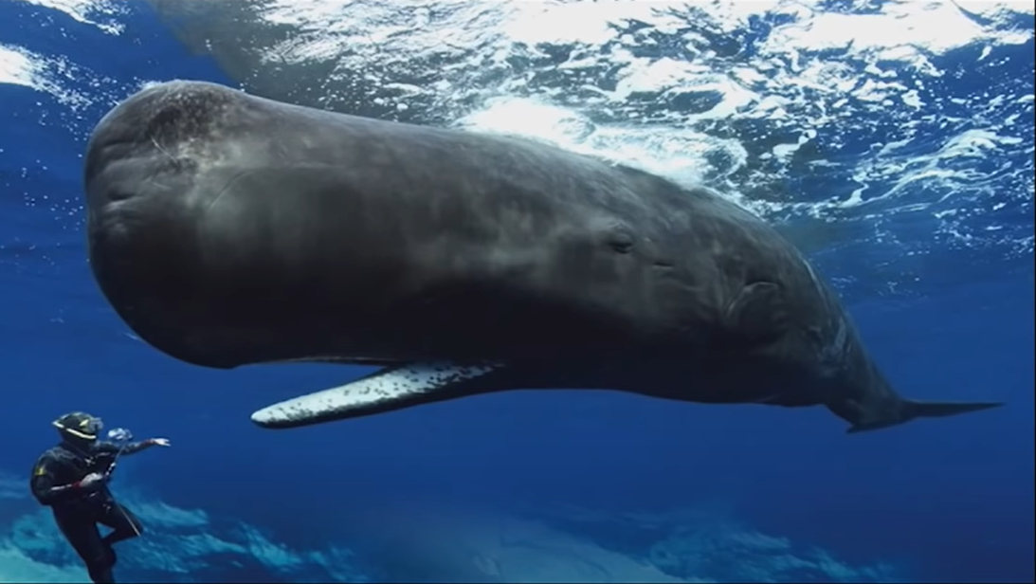
Names, Dates, Uses and Facts | ____________________________________  ____________________________________  ____________________________________  ____________________________________  ____________________________________  ____________________________________  ___________________________________ | ____________________________________  ____________________________________  ____________________________________  ____________________________________  ____________________________________  ____________________________________  ___________________________________
KEY INFORMATION ABOUT THE SOUNDS  How loud/quiet?  Who can hear it? | ____________________________________  ____________________________________  ____________________________________  ____________________________________  ____________________________________  ____________________________________  ____________________________________  ___________________________________ | ____________________________________  ____________________________________  ____________________________________  ____________________________________  ____________________________________  ____________________________________  ___________________________________  ___________________________________
Sound Science Research Task

