Red Class Sentences – W/C 15th June
- Please encourage your child to read these sentences to you.

- Next, slowly, one word at a time read the sentences to your child and get them to write the sentence in their home learning book.

- Each child should be writing two per day.

- If your child would like to write more, which is great, ask them to come up with their own sentence. Please remember - When supporting your child with their writing it is important that you allow them to use their phonic knowledge to write words in ways which match their spoken sounds. Therefore if your child is writing the word fish and they can't hear the 'sh' sound at the end this is where they are developmentally and it is important to support that. In class we would add a little annotation in a different colour pen after their writing to help add meaning to their marks.

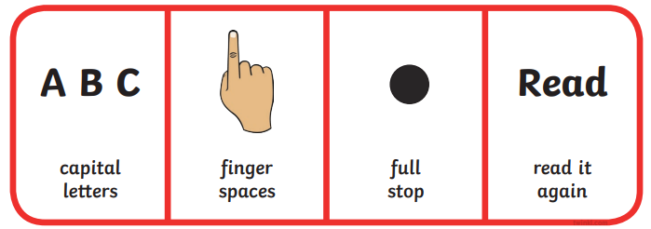
- This is an ant.
- Look at the sun it is big.
- I can see the fish.
- We went to the shop.
- The pan is hot.
- I went into the chip shop.
- We can see the sunset.
- Kick the mud on the ball.
- I am sick.
- Mum went on a rocket.
- Pick up the mug and the cup.
- Hug the rabbit.
- Bill has his doll.
- Goodnight mum and dad.
- The fox is in the van.
- Will you sit with me?
- Sell the laptop.
- Huff and puff can see us.
- I am the boss.
- Can I see the red car?

