Red Class Sentences – W/C 27th April
- Please encourage your child to read these sentences to you.

- Next, slowly, one word at a time read the sentences to your child and get them to write the sentence in their home learning book.

- Each child should be writing two per day.

- If your child would like to write more, which is great, ask them to come up with their own sentence. Please remember - When supporting your child with their writing it is important that you allow them to use their phonic knowledge to write words in ways which match their spoken sounds. Therefore if your child is writing the word fish and they can't hear the 'sh' sound at the end this is where they are developmentally and it is important to support that. In class we would add a little annotation in a different colour pen after their writing to help add meaning to their marks.

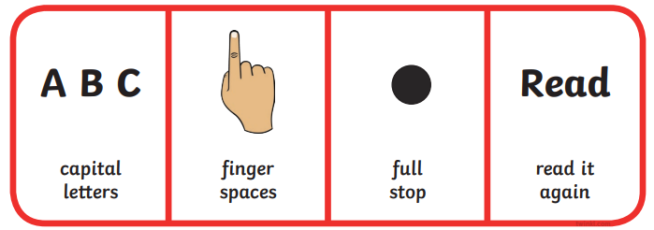
- The big bus is red.
- A man has a van.
- I ran to the shop.
- The pan is hot.
- The dog sits on a rug.
- I can see into the bag.
- This frog is green.
- Jen has a big hat.
- That is so high.
- I go to sleep at night.
- The queen has lots of dogs.
- I can chop my food.
- Bob is in the den.
- You can see the sun.
- I will lick the chip.
- This is a fox.
- The wing is long.
- Dad is a bit sad.
- Sam has a bad leg.
- The pig is in the bin

