Litterbug Doug and Michael Recycle have a group each.
Write ‘more, ‘less’ or ‘equal’ phonetically beside each group and write the numeral in the picture box for each. Sheet 1
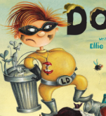
Litterbug Doug and Michael Recycle have a group each.
Look at the items that Michael Recycle has. For each draw a group that shows ‘more’, ‘less’ or ‘equal’.
I have done one for you. Sheet 2
Now draw your own, look at each box to see if you need to draw ‘more’, ‘less’ or ‘equal’ to the group.
More

less
equal
more
equal
more
less
less
equal

