Red Class Sentences – W/C 6th July
- Please encourage your child to read these sentences to you.

- Next, slowly, one word at a time read the sentences to your child and get them to write the sentence in their home learning book.

- Each child should be writing two per day.

- If your child would like to write more, which is great, ask them to come up with their own sentence. Please remember - When supporting your child with their writing it is important that you allow them to use their phonic knowledge to write words in ways which match their spoken sounds. Therefore if your child is writing the word fish and they can't hear the 'sh' sound at the end this is where they are developmentally and it is important to support that. In class we would add a little annotation in a different colour pen after their writing to help add meaning to their marks.

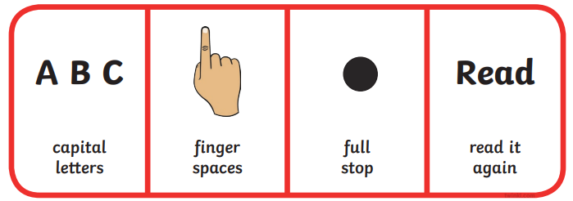
- I can paint.
- The bee went buzz.
- At night I go to sleep.
- I can see a snail in the rain.
- I might go on the boat.
- The goat is six.
- The light is on.
- I can smell the soap on my hands.
- She might go all the way back.
- The snail went in the rain.

