Red Class Sentences – W/C 1st June
- Please encourage your child to read these sentences to you.

- Next, slowly, one word at a time read the sentences to your child and get them to write the sentence in their home learning book.

- Each child should be writing two per day.

- If your child would like to write more, which is great, ask them to come up with their own sentence. Please remember - When supporting your child with their writing it is important that you allow them to use their phonic knowledge to write words in ways which match their spoken sounds. Therefore if your child is writing the word fish and they can't hear the 'sh' sound at the end this is where they are developmentally and it is important to support that. In class we would add a little annotation in a different colour pen after their writing to help add meaning to their marks.

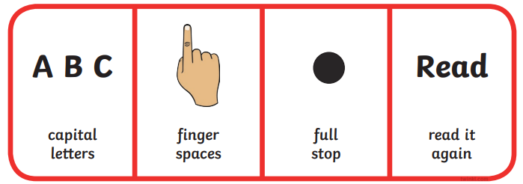
- I can see the moon.
- Dan is in his big red van.
- The shop was small.
- We went to see the queen.
- All I can see is a fish in the pond.
- Dad went into the chip shop.
- Me and (enter friend/siblings name) are good.
- I can see six books.
- The boat has a sail.
- Buzz went the bee on my lap.
- You are so tall.
- Her dog ran up the hill so fast.
- The ball is quick.
- Was that you Dad? (Question marks are new learning)
- Shut the door so the cat can sleep all night.
- I can see ten dogs in the pen.
- I did a quiz and I was right.
- Ping went the pan.
- Fizz and Fozz are my pet snails.
- We are all in red class.

