History Action Plan
2025-2026

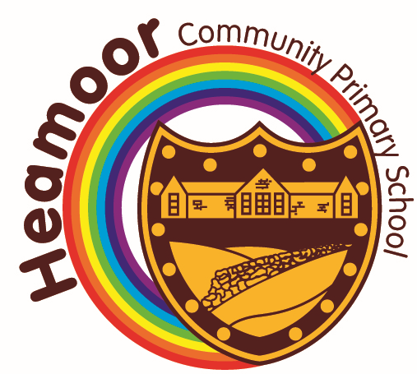
Success criteria | Action(s) to be taken | Who is responsible? | Who is involved? | Start/ finish dates | Monitoring of implementation |  |  | Evaluation against success criteria
A  Success is:  Children accessing a range of outings and experiencing visits in school or virtually that enhance their learning throughout the history curriculum. | Plan out a calendar of events to enhance the Curriculum, linking to the new scheme but keeping a focus on local Cornish heritage |  |  | Academic year 25/26  Each term, progress will be reviewed | How?  See implementation plan | Who? | When?  Termly | How?  Overview of calendar events in place, children experiencing high quality learning opportunities. | Who? | When?  By June 2026
B  Success is:  A cross curricular approach to History across the school. | A detailed look across the curriculum to ensure that History is taught across other subjects. |  |  | Academic Year 2025/2026 | Implementation Plan |  | Termly | Monitor implementation plan |  | Termly
C  Success Criteria:  History for children with SEND is taught in a multi-sensory way and recorded in alternative ways if required. | Review planning to ensure that SEN needs are being met.  Review learning journeys throughout for evidence of history.  Review the impact of differentiated strategies to meet the needs of SEN children. |  |  |  | Implementation Plan |  | Termly | Monitor implementation plan |  | Termly

Implementation Plan
Action | Autumn 2025 | Spring 2026 | Summer 2026 | Progress update Summer 2026
A | Research into the local area and find out which museums/galleries offer workshops to schools. Plot out trips and visitors to the school. | Begin to create a display that celebrates children’s learning through trips and visitors and gather children’s feedback to be included on the display. | Meet with staff to discuss the impact of the trips and begin to add further selections to the P drive for the next year ahead.
B | Hold a staff meeting with other subject leaders to identify where History could be linked to other subjects- taking into account the new scheme and any adaptations that are needed. Create an overview document to show this cross curricular approach | Observe lessons and collect samples of children’s work to demonstrate the cross curricular learning approach. | Use the evidence that you have to evaluate the impact, identify best practice and address any future challenges.
C | Review planning and do drops in to lessons to find out how children with SEN are accessing the curriculum. | Review the learning journeys throughout Key Stage 1 to find evidence of children experiencing learning about history. | Review the impact of what we do and plan further CPD/actions to move history for children with SEND forwards.

